Assignment 2 Task 2 – Requirements and Instructions to students

Scenario:

Andromeda Productions are a computer animation company specialised in production and editing of animated films. Their recent collaboration with Walt Disney Animation Studios has been a success, and the company experienced quite an extensive growth during the past year. As a result, at their location, they decided to buy some offices across the street, where previously used to be an IT company. In these new premises, they will relocate their graphics and video editors, in order to allow more room for animations in the current location.

You will need to design the network according to the floor plan and the network requirements provided below (floor plan provided as JPEG as well):

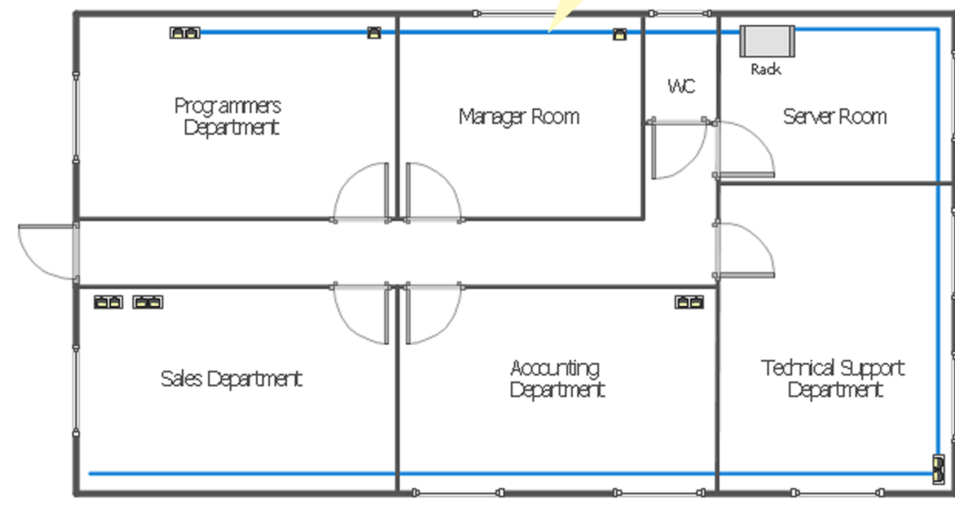

The network requirements for the departments you see on the floor plan are as follows:

Programmers/Graphic Designers – 10

Manager Room – 3

Server Room will be used to host the servers and routers – 2 servers (routers are your decision)

Sales Room will host Animations Dept – 10

Accounting/HR/Marketing – 6

Technical Support - 6

You are given a specific IP addressing range by your line manager (tutor) in a spreadsheet. The IP addresses will be different for each of you. It is clear from the screenshot above that there are other IP addressing configuration parameters that you have to decide yourself what they can be. They have been left empty on purpose. You can start implementing the diagram on Packet Tracer, but your work does not actually start on Packet Tracer. It starts on paper, by deciding on the IP addressing parameters that are missing, and then creating the IP addressing scheme in table format You have been provided with an example of IP address table, but you are invited to use it only as a guide. You might need to change the table structure to fit your purpose. An IP address table is detailed and complete, when another person that is tasked to implement your IP addressing scheme will not need to ask questions about what to configure where.

On Packet Tracer, you need to create the network, configure all the PCs, the servers, and the LAN interfaces on the router. The servers will be configured with services as per the diagram. One of them is an Email server, and the other one is a DNS server. To users with names of your choice must be able to send emails to each-other. You have to plan your work first. Where would you start and what would you do first?

Wherever you start and whatever you decide to do first, when the PCs and server can ping their default gateways, then the initial IP configuration is implemented correctly.

Then, the other aspect of your work is the configuration of the other services – DNS, and Email. After services are configured correctly, then the clients can be configured. However, the order of your work is for you to decide.